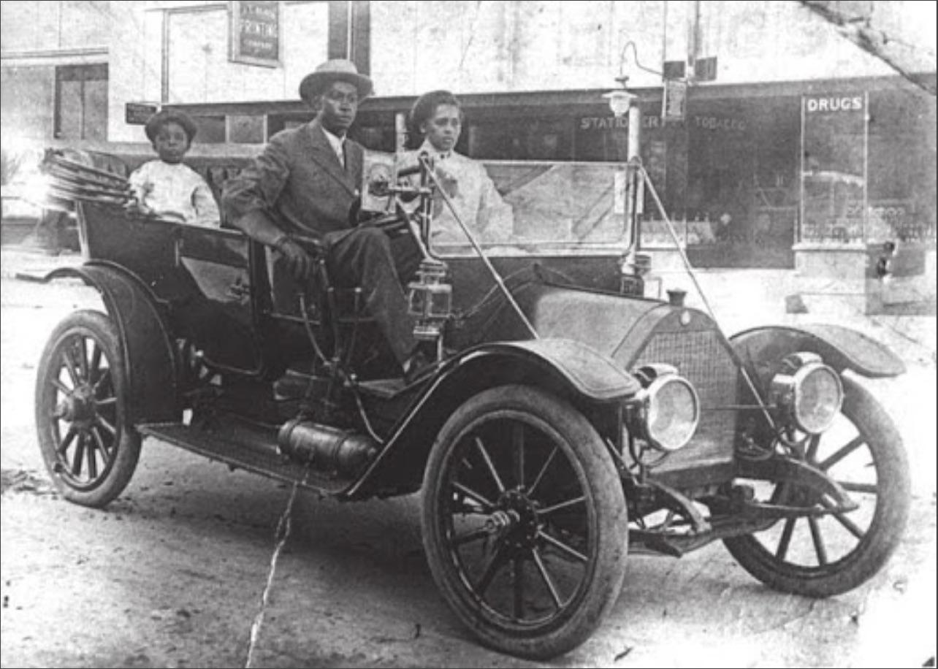

Source:[www.researchgate.net/publication/332891482_Bullets_and_Ballots_Destruction_Resistance_and_Reaction_in_1920s_Texas_and_Oklahoma/figures?lo=1](https://www.researchgate.net/publication/332891482_Bullets_and_Ballots_Destruction_Resistance_and_Reaction_in_1920s_Texas_and_Oklahoma/figures?lo=1)

***John and Loula Williams*** were some of Greenwood’s earliest residents, moving to Tulsa in 1903 from Arkansas. In 1912, John opened an auto-repair shop called Williams’ One Stop Garage, at 420 E. Archer St., providing services for both Black and white Tulsa citizens. Here, John, Loula, and their son, Bill, take a ride through Greenwood past local businesses.

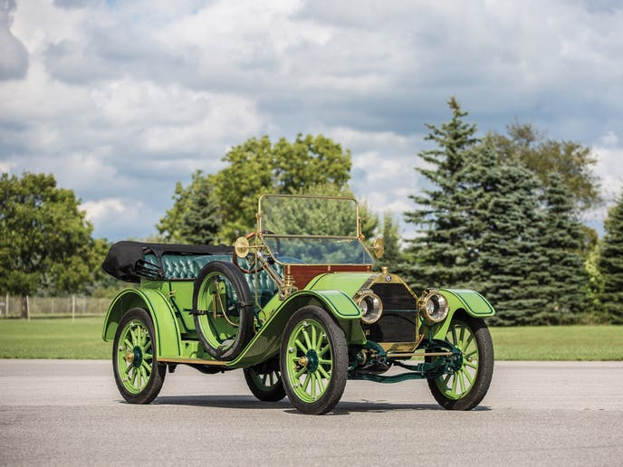

Source: https://www.classic.com/a/rm-sothebys-hershey-2016-ln1Pg4B/lots/1911-chalmers-thirty-pony-tonneau-8p6e1LW/

John was the first in the Greenwood community to own a car. The car, a Chalmers “Thirty Pony Tonneau,” was named because of its 30 horsepower and inline four-cylinder engine. The value of the car was $1,600 in 1911, which would be $53,000 today. The car had a three-speed manual transmission, comfortable leather seats, and a maximum speed of 50 miles per hour.